34.80: a) 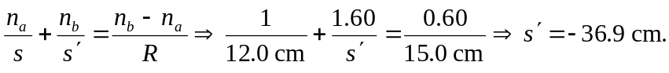 So the object distance for the far end of the rod is 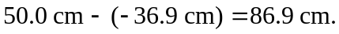
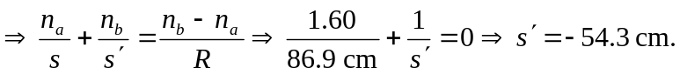
b) The magnification is the product of the two magnifications:
